**Project Report**

1.Project Title: Online move store

2.Name for the Website: Movie Store

3.Project Description:

(1)3 kind of served users: guest user, regular user and admin user.

(2)User’s available function:

Guest user: seeing all the movie’s list, searching specific movie by name, filter the result by category, see the detail of a specific movie, register with validated user name, email and password.

Regular user: log in with registered username/email and password, add to and remove movie from shopping cart and check out, see the purchase history, log off.

Admin user: log in with registered username/email and password which added into admin table of database by database administrator, add new movie (including upload movie picture and summery), update exist movie with new content or delete exist movie (soft delete: mark the isDeleted attribute in movie table as 1 which default 0.), log off.

4.Database Design:

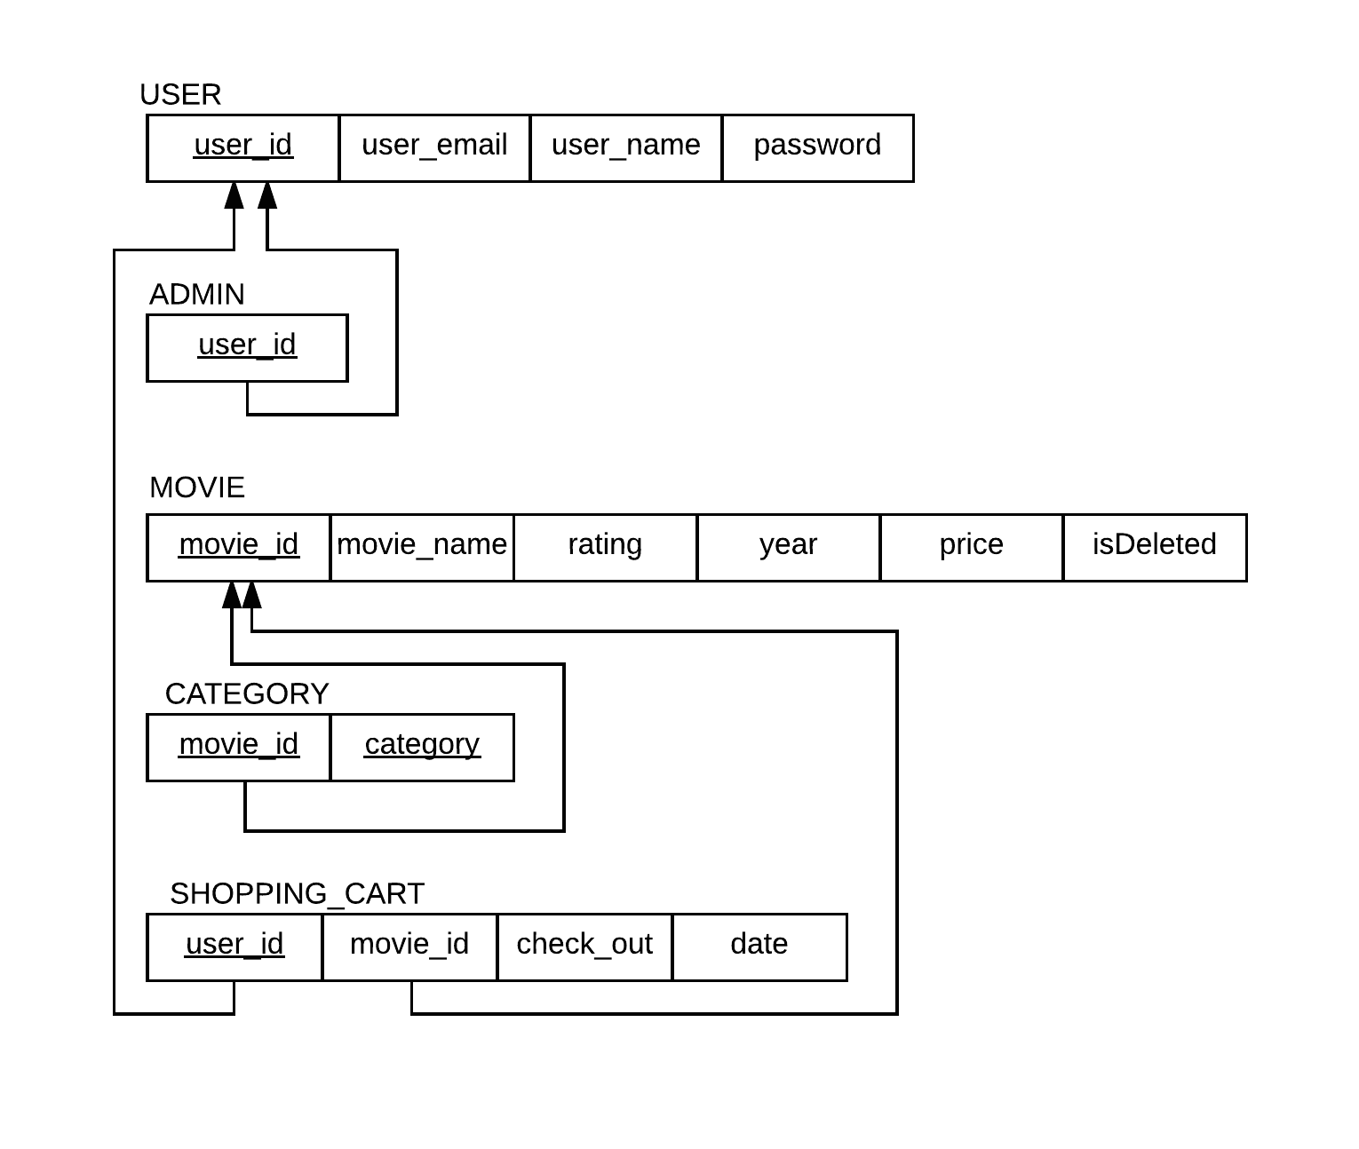

SQL statement:

DROP DATABASE IF EXISTS MOVIE_STORE;

CREATE DATABASE MOVIE_STORE;

USE MOVIE_STORE;

DROP TABLE IF EXISTS USER;

CREATE TABLE USER (

user_id int not null AUTO_INCREMENT,

user_email varchar(40) not null,

user_name varchar(40) not null,

password varchar(80) not null,

CONSTRAINT pk_user PRIMARY KEY (user_id),

CONSTRAINT uk_user_email UNIQUE (user_email),

CONSTRAINT uk_user_name UNIQUE (user_name)

);

DROP TABLE IF EXISTS ADMIN;

CREATE TABLE ADMIN (

user_id int not null,

CONSTRAINT pk_admin PRIMARY KEY (user_id),

CONSTRAINT fk_admin FOREIGN KEY (user_id) REFERENCES USER(user_id)

);

DROP TABLE IF EXISTS MOVIE;

CREATE TABLE MOVIE(

movie_id int not null AUTO_INCREMENT,

movie_name varchar(40) not null,

movie_rating varchar(10) not null,

year varchar(5) not null,

price float(10,2) not null,

isDeleted int(2) DEFAULT 0,

CONSTRAINT pk_movie PRIMARY KEY (movie_id),

CONSTRAINT uk_movie UNIQUE (movie_name)

);

DROP TABLE IF EXISTS CATEGORY;

CREATE TABLE CATEGORY (

movie_id int not null,

category varchar(40) not null,

CONSTRAINT pk_category PRIMARY KEY (movie_id, category),

CONSTRAINT fk_category FOREIGN KEY (movie_id) REFERENCES MOVIE(movie_id)

);

DROP TABLE IF EXISTS SHOPPING_CART;

CREATE TABLE SHOPPING_CART (

user_id int not null,

movie_id int not null,

check_out boolean not null,

date date not null,

CONSTRAINT pk_shopping_cart PRIMARY KEY (user_id, movie_id),

CONSTRAINT fk_shopping_cart_user FOREIGN KEY (user_id) REFERENCES USER(user_id),

CONSTRAINT fk_shopping_cart_movie FOREIGN KEY (movie_id) REFERENCES MOVIE(movie_id)

);

5.Languages/frameworks used for implementation

(1) Language: HTML, CSS, JavaScript, PHP, JSON, AJAX.

(2) Framework: Bootstrap

6.Screenshots for main functionalities



picture 1: homepage

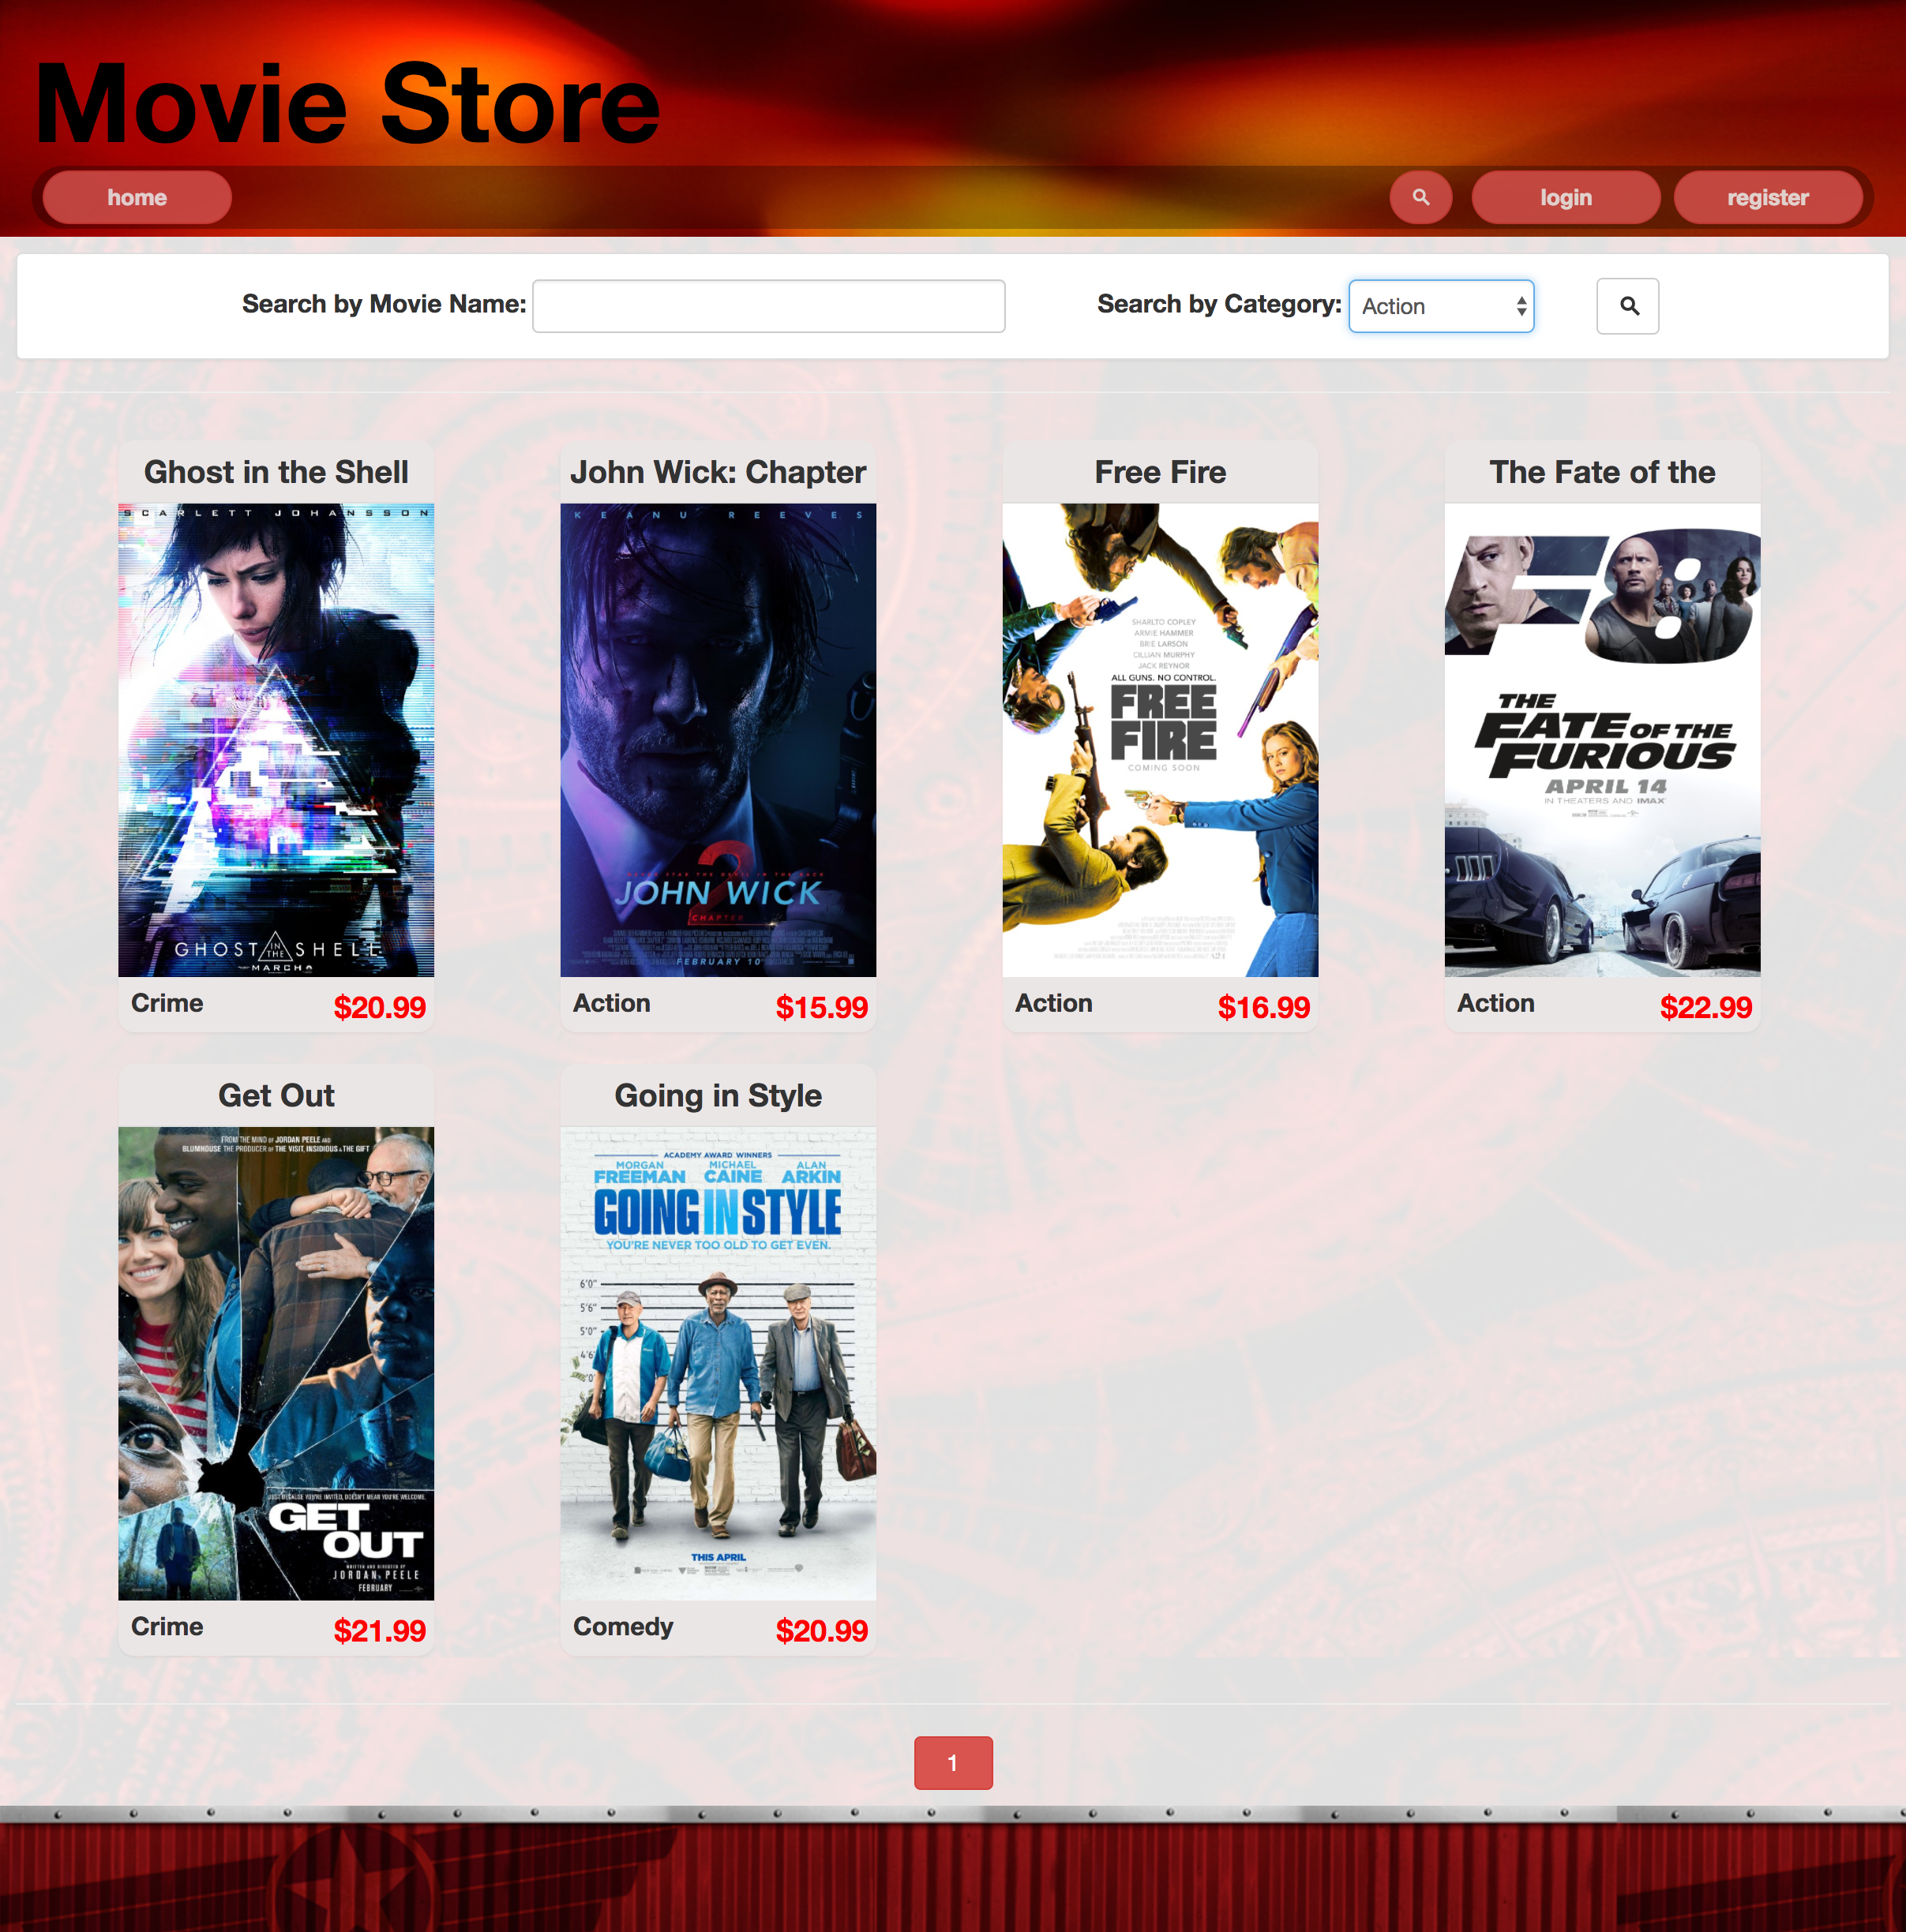

picture 2: search and filter

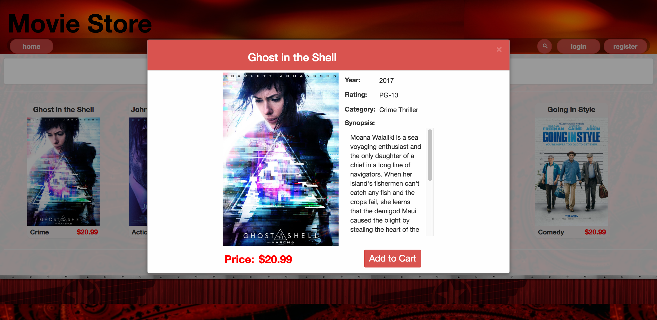

picture 3: detail

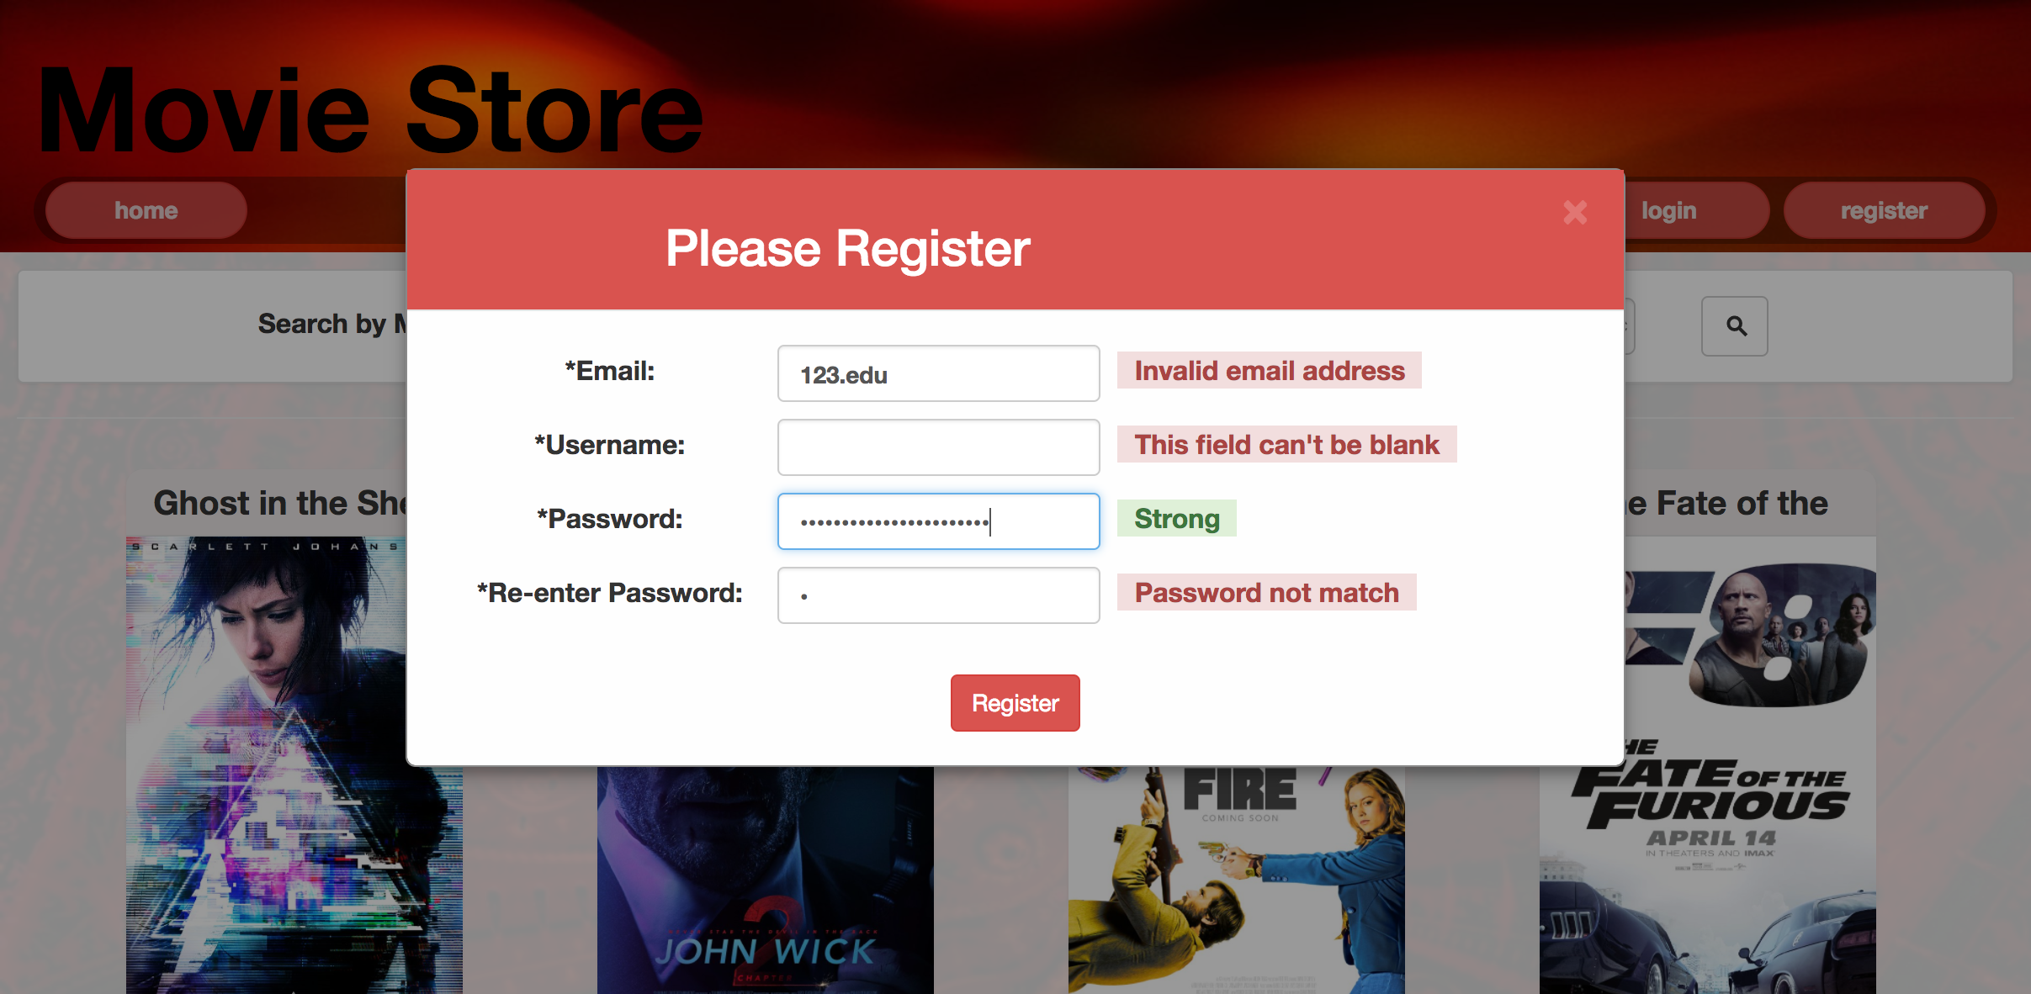

picture 4: register and validation

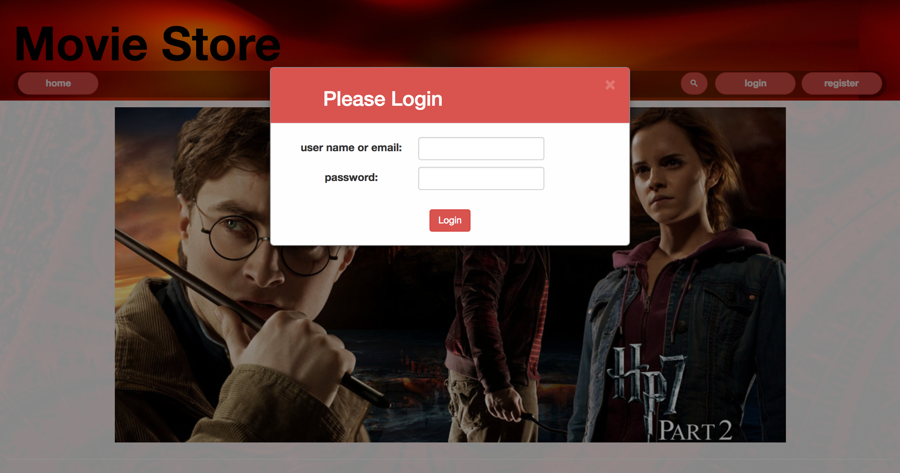

picture 5: login



picture 6: menu

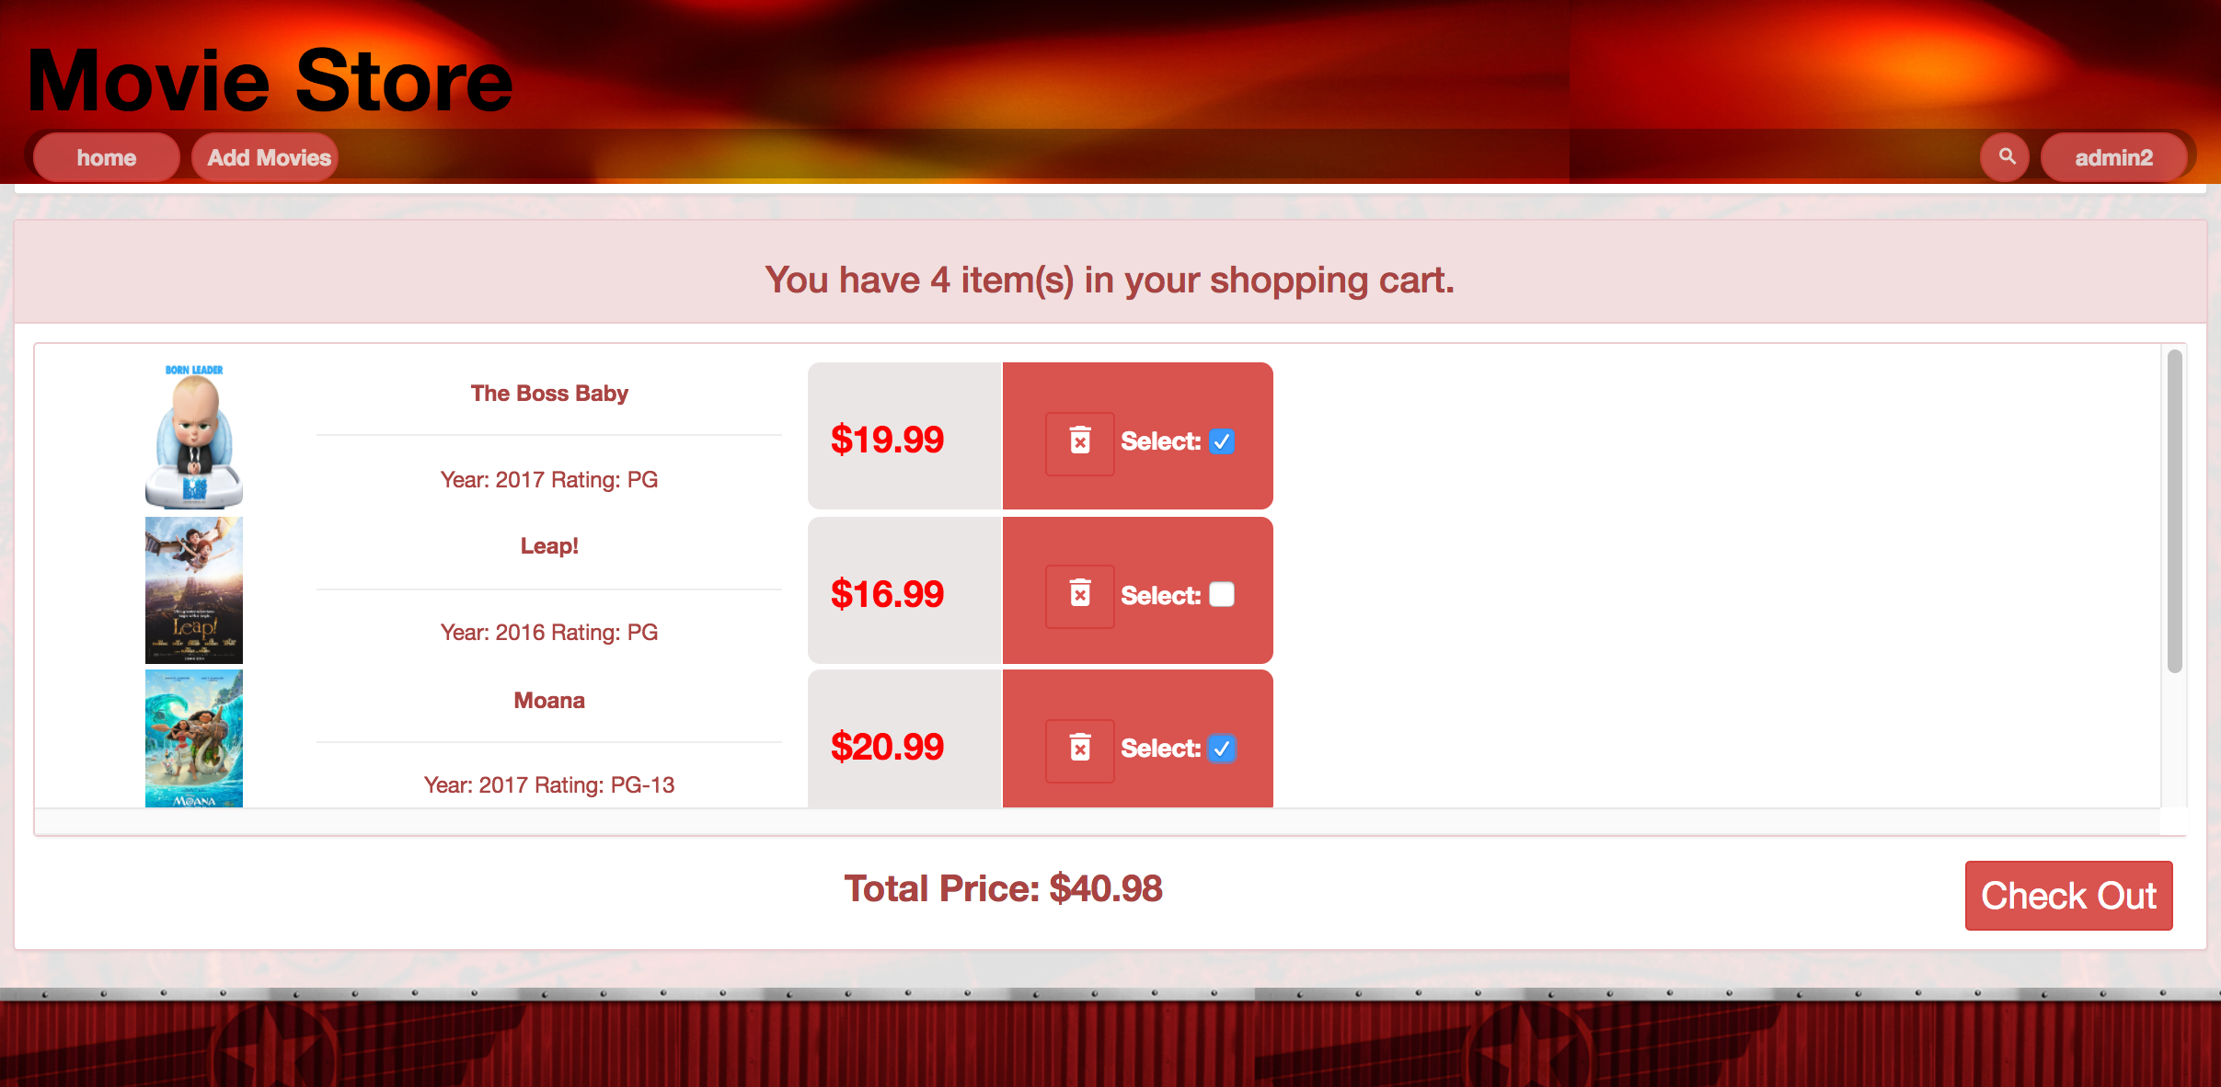

picture 7: shopping cart and check out

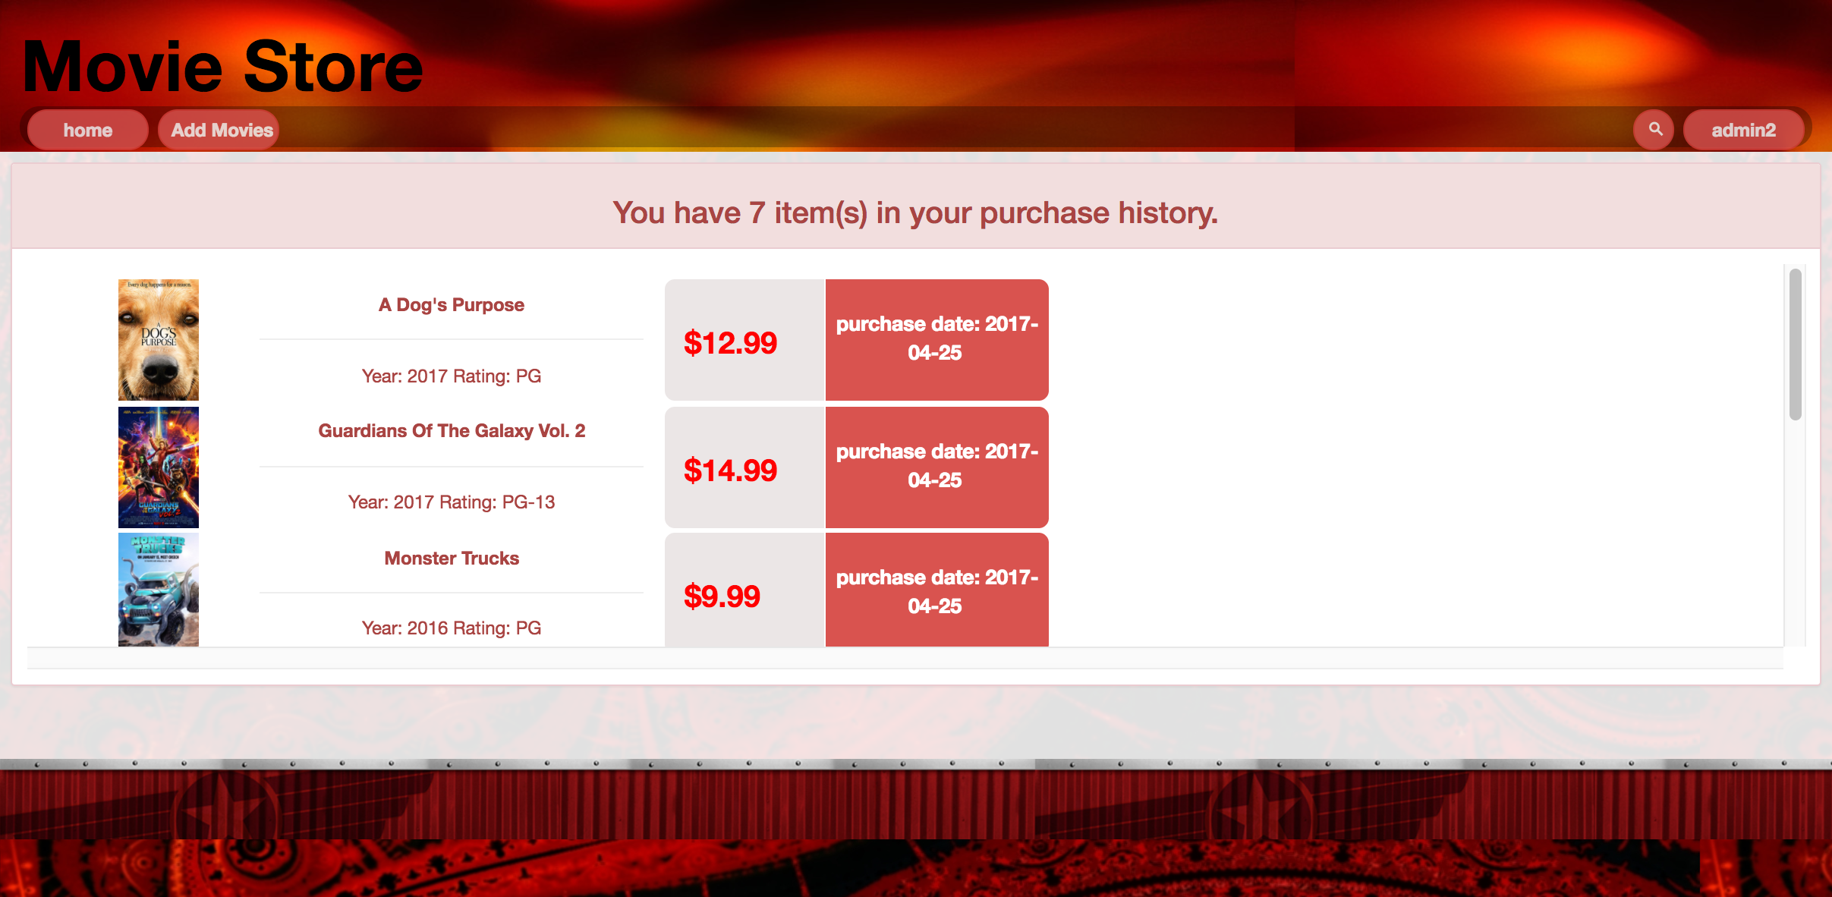

picture 8: purchase history

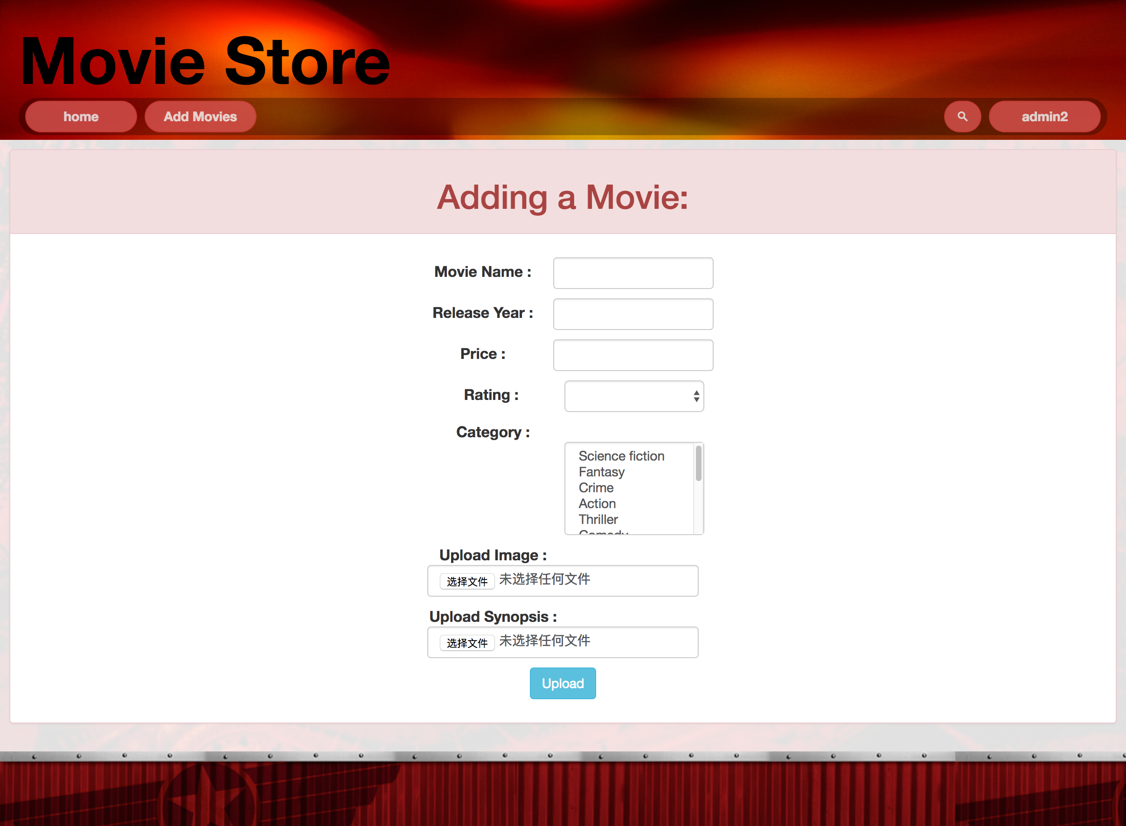

picture 9: add movie

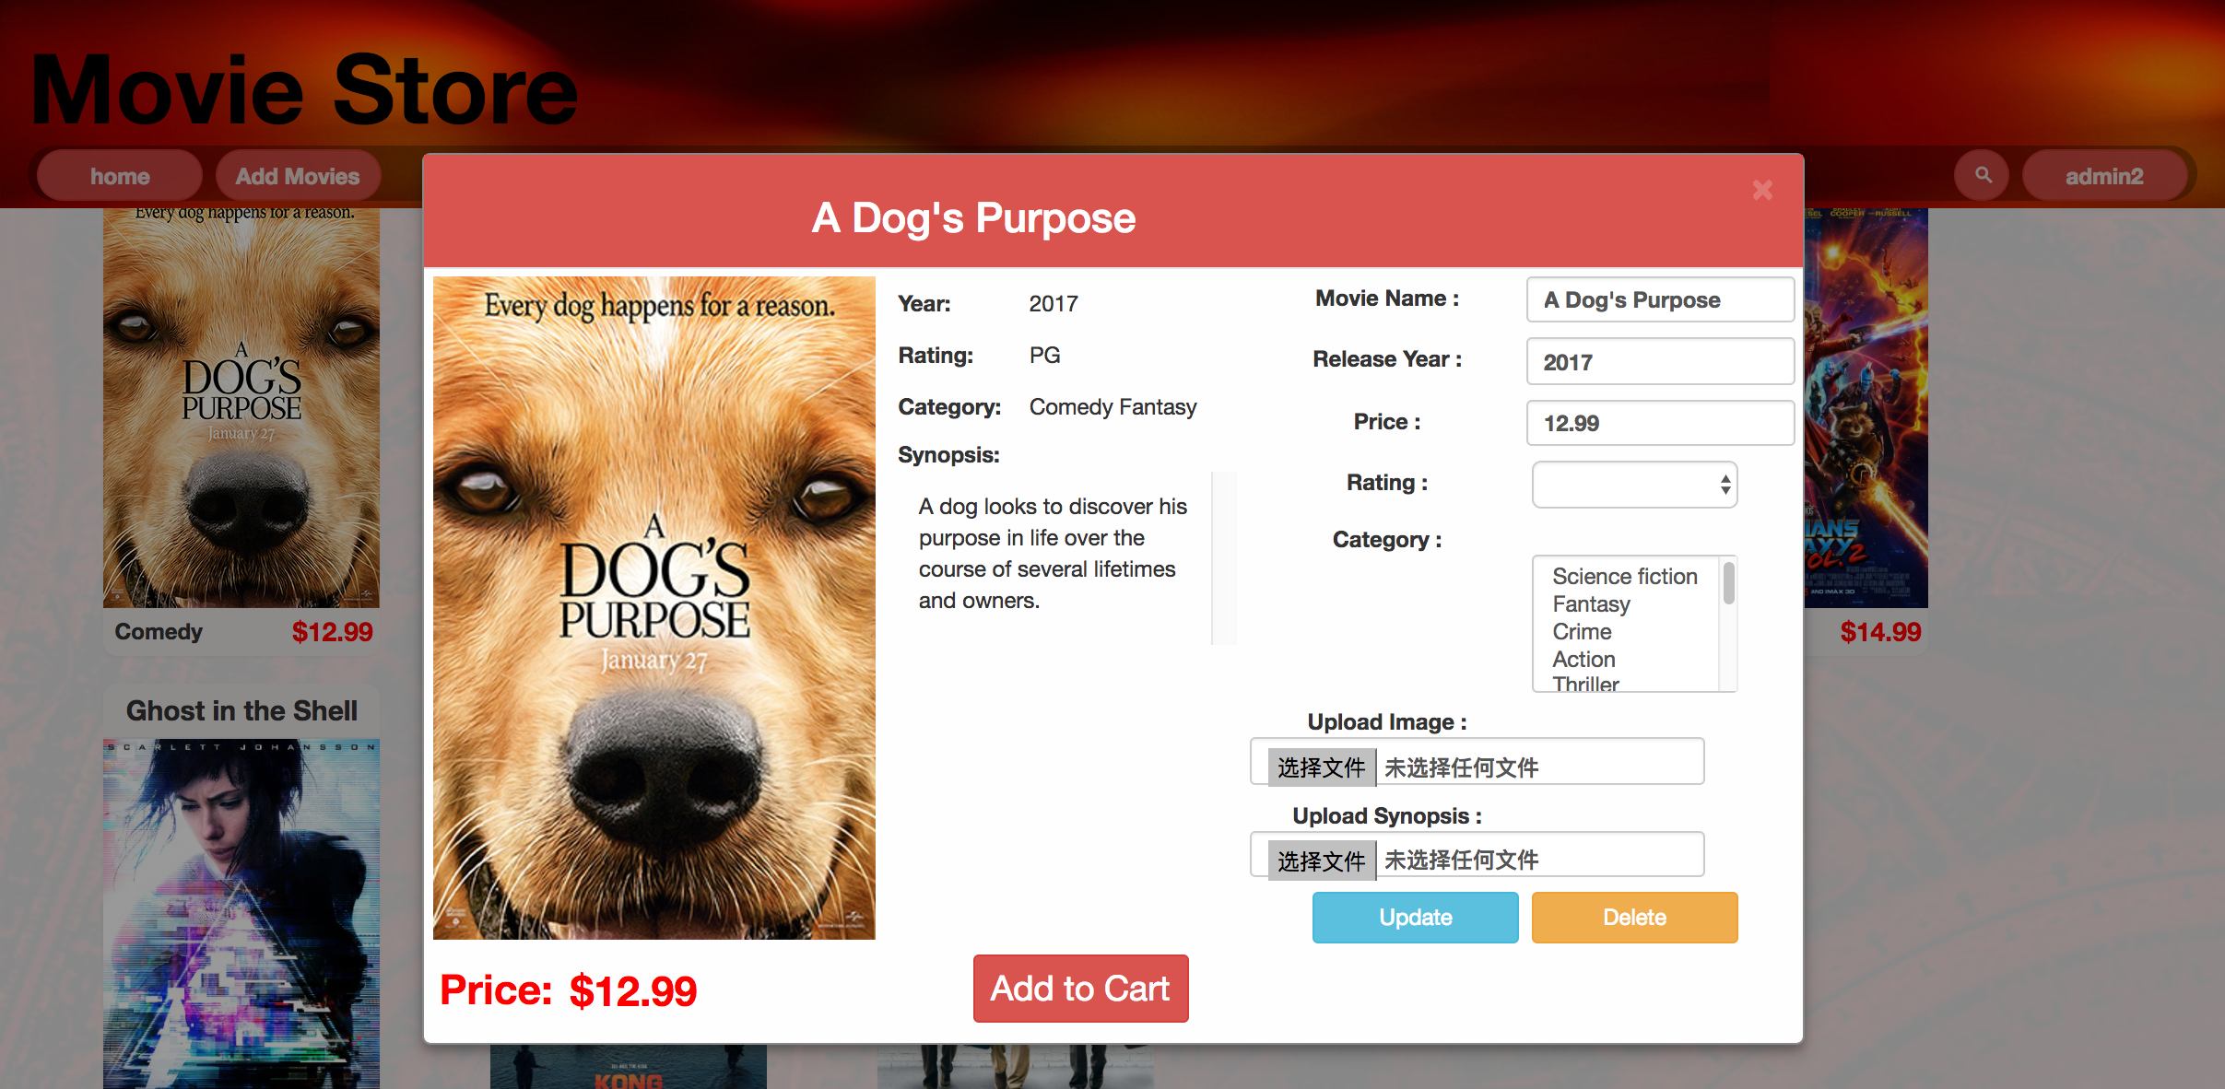

picture 10: update and delete

7.Team Members and work division:

|  |  |  |
| --- | --- | --- |
| Name | NetID | Work devision |
| Jiafeng Liao | jxl155830 | Add movie module, Filter movie module, Update movie module, Front and back end ajax communication regulation, Web frame design and edit, Web style sheet edit, front end script. |
| Biyun Shi |  | Paging creation, Movie detail module, Shopping cart module, homepage movie slider, |
| Yu Gong | yxg162930 | Login module, Register module, Delete movie module, History module, Database design, ajax file communication, |